# Create an event hub using Azure portal.

Azure Eventhub is a streaming platform and event ingestion service that process millions of events. Eventhub processes events and data produced by distributed systems. Events/Data can be read from an eventhub using a client code or batching/storage adapters.

## Before Starting:

You need to have a valid Azure subscription. If not, please create an Azure account.

## Let’s Begin:

Create a Resource Group

A resource group is a logical collection of all Azure resources. All resources are deployed and managed in a resource group.

* Sign in to Azure Portal using your credentials.

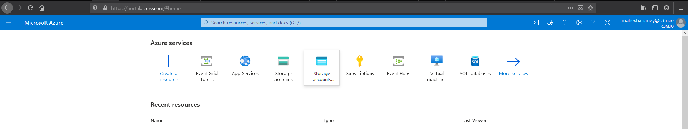

* In the left navigation, select **Resource groups**. Then select **Add**.

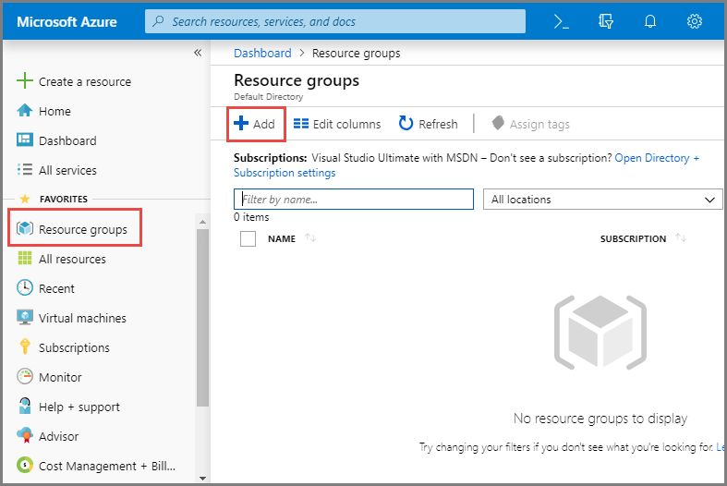

* Alternatively, you may click on “Create a resource”

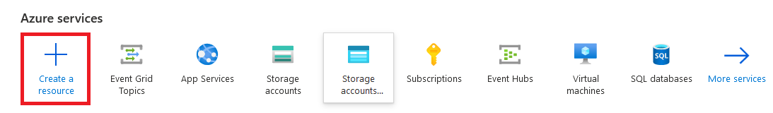

The “New” resource page will be loaded, in the search text at the top, type Resource Group and choose “Resource Group”

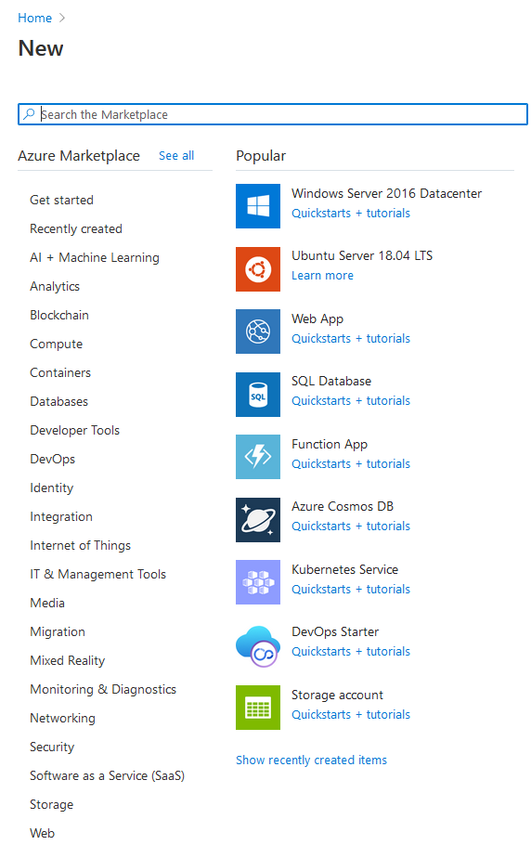

The Resource Group page is loaded.

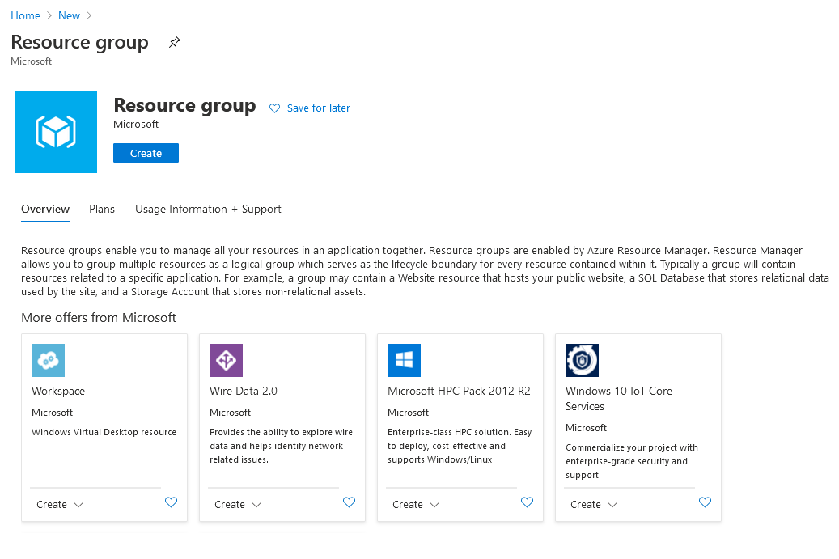

* Click on “**Create**” button and “**Create a resource group**” page is loaded.

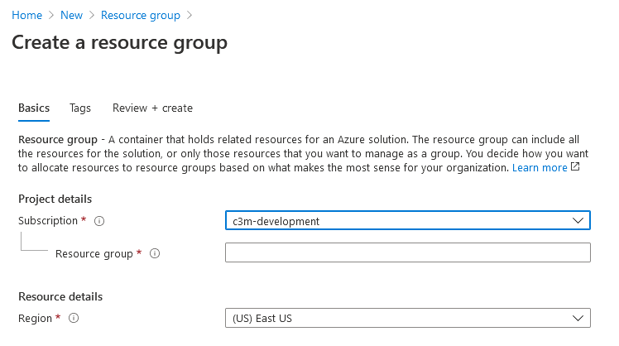

Select the name of the Azure subscription in which you want to create the resource group.

Keyin a unique **name for the Resource group**. Azure will check to see if the name is available in the currently selected Azure subscription. If the resource exists, Azure will bring-up an error message stating that the resource group name you chose already exists.

* Select a **region** for the resource group. By default (US) East US is selected.
* Click on **Review + Create** button.

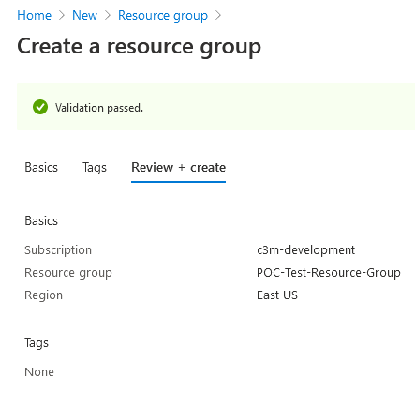

A validation passed page is loaded, when Azure accepts your keyed-in name as a unique name.

* Click on the “**Create**” button at the bottom of the page.

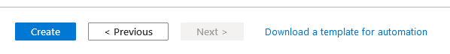

The resource group is created and will listed in your home page.

Create an Event Hubs namespace

An Eventhub namespace provides a unique scoping container, in which you create one or more eventhub. Create a namespace in the newly created resource group, perform the following steps;



* The “New” resource page will be loaded, in the search text at the top, type Event Hub and choose “Event Hubs”.

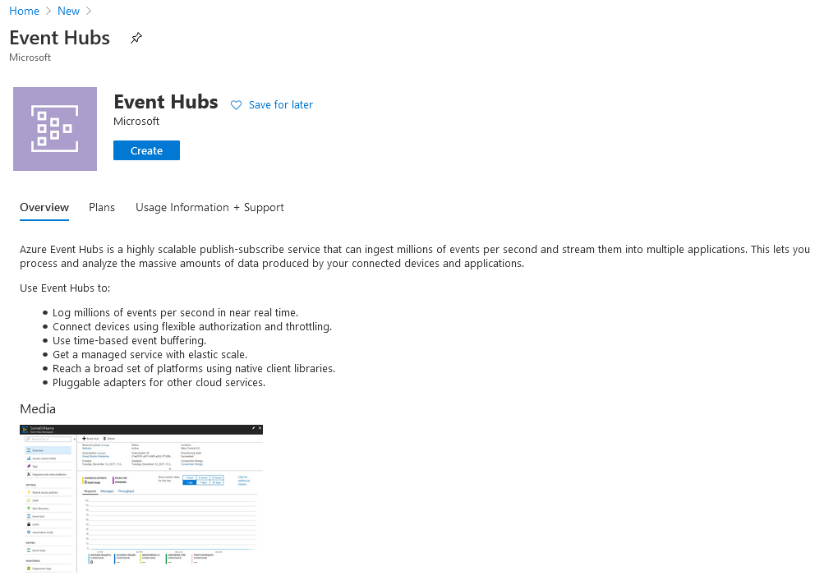

* Click on “Create” button. “Create Namespace” page is loaded.

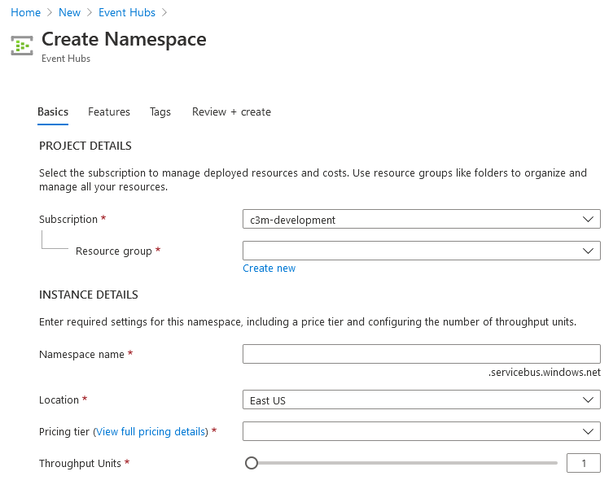

* Select the **subscription** [C3M-Development] in which you want to create the namespace.
* Select the **resource group** you just created.
* Enter a name for the **namespace**. Azure checks to see if the name is available.
* Select a **location** for the namespace, defaults to **East US**.
* Choose the **pricing tier** (Basic or Standard). [ I choose Basic]
* Leave the **throughput units** settings as it is. Defaults to 1.
* Select **Review + Create** at the bottom of the page.



Create Namespace validation page is loaded

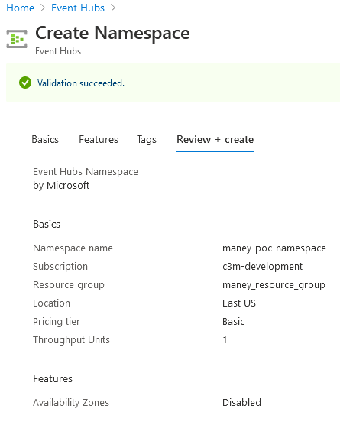

* Click on “**Create**” button at the bottom of the page.



As soon you click on create button, the deployment page is loaded.

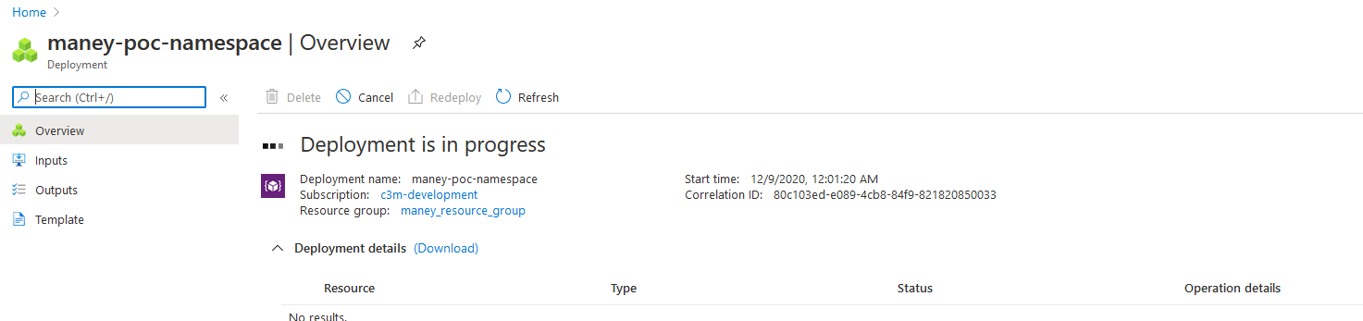

The deployment will take about a minute and half to complete the task. Once the deployment is successful, the following page is loaded.

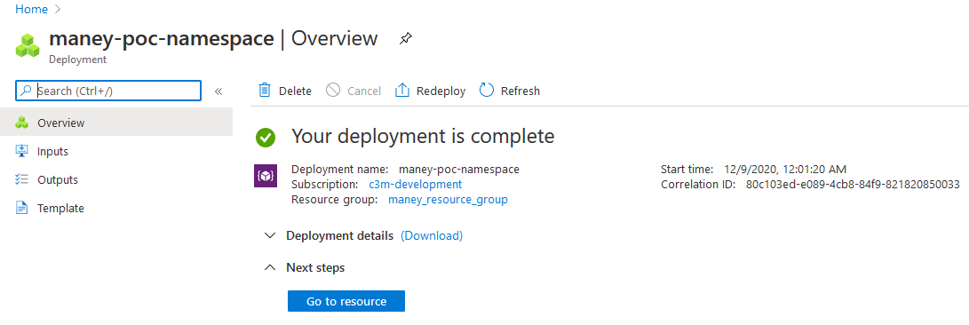

Now click on “**Go to resource**” button. With all the metadata on the page and after 10-15 seconds the page is completely loaded with graph depicting the metrics. Make sure your page appears similar to the below screenshot.

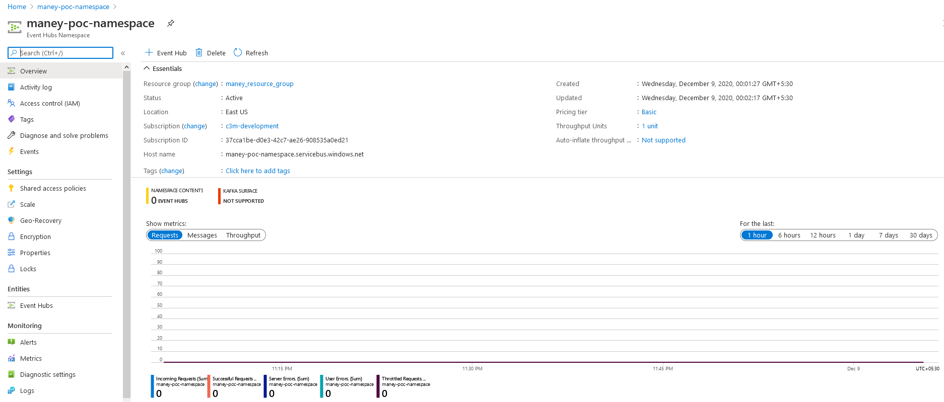

Create an Event Hub.

We shall create an event hub within the just created namespace. Perform the following steps;

* At the top of the window, select “**+ Event Hub”**.

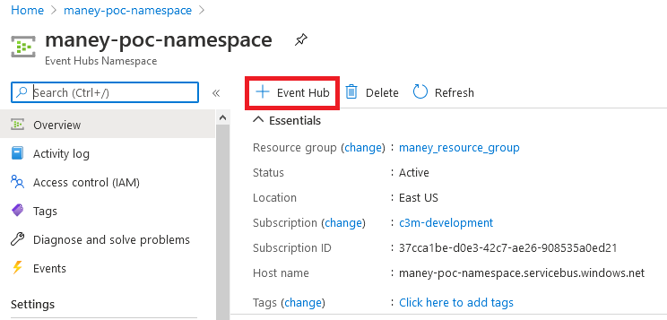

* Create Event Hub page is loaded.

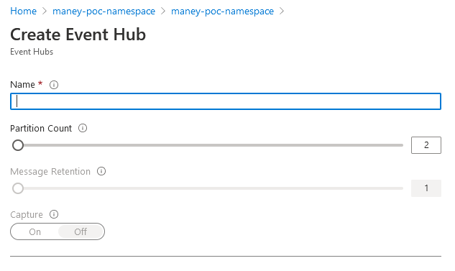

keyin a name for you’re the event hub you want to create, then select **Create**.

[Keep the default values for “Partition Count” as 2 and “Message Retention” as 1]

* Click on “Create” button at the bottom of the page.



A small window “Creating….” Message will appear on top right side of the window. In 4-5 seconds, the event hub is created and will take you back to Namepsace page.

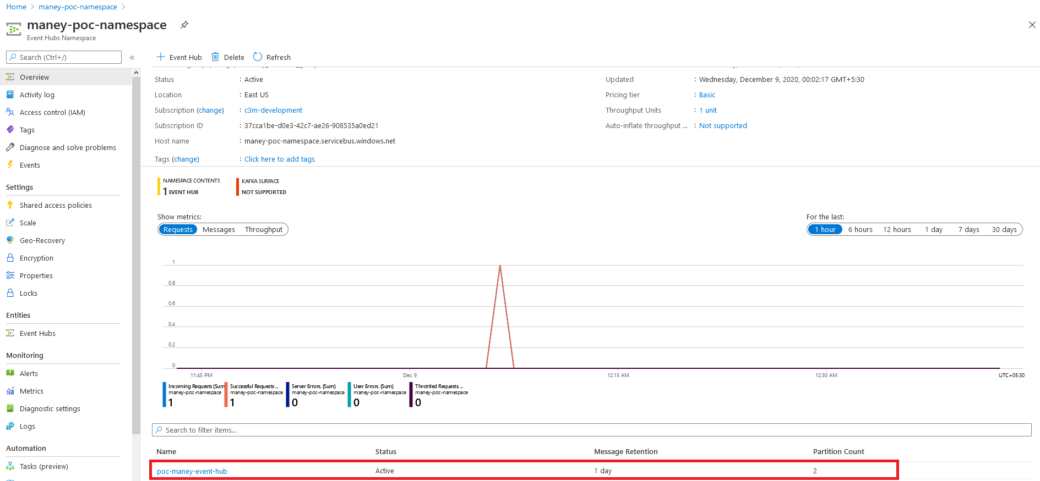

You can check the status of the event hub creation in alerts. After the event hub is created, you see it in the list of event hubs.

Attach a **Diagnostic Settings** to the Namespace

Click on Activity Log

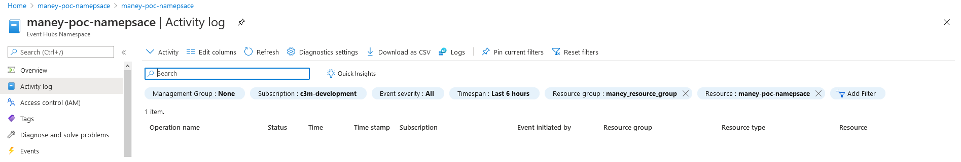

Activity log page is loaded. Click on **Diagnostic Settings**

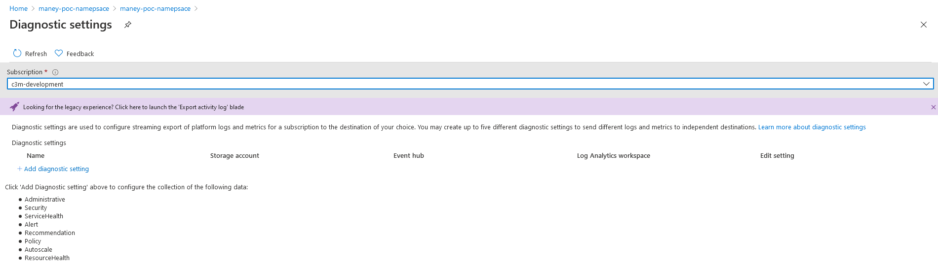

Diagnostic Settings page is loaded. Click on **+ Add diagnostic Settings**

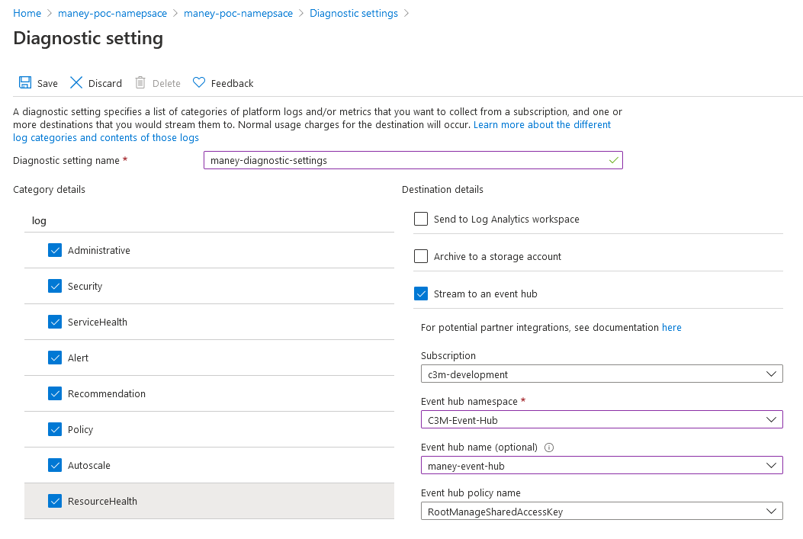

Key-in a name to **Diagnostic setting name**

Select all checkboxes under **Category details**

Select **Stream to an eventhub** under Destination Details

Choose the **subscription** where the namespace was created from the dropdown box.

Select **Event hub namespace** from the dropdown box

Select the **Event hub**, that was created, from the dropdown box

Select the **Event hub policy name** from the dropdown box.

Click **save.**

[Note : Category Details]

|  |  |
| --- | --- |
| Category | Description |
| Administrative | Contains the record of all create, update, delete, and action operations performed through Resource Manager. Examples of Administrative events include create virtual machine and delete network security group.  Every action taken by a user or application using Resource Manager is modeled as an operation on a particular resource type. If the operation type is Write, Delete, or Action, the records of both the start and success or fail of that operation are recorded in the Administrative category. Administrative events also include any changes to Azure role-based access control in a subscription. |
| Security | Contains the record of any alerts generated by Azure Security Center. An example of a Security event is Suspicious double extension file executed. |
| ServiceHealth | |  |  | | --- | --- | |  | Contains the record of any service health incidents that have occurred in Azure. An example of a Service Health event *SQL Azure in East US is experiencing downtime*.   Service Health events come in Six varieties: *Action Required*, *Assisted Recovery*, *Incident*, *Maintenance*, *Information*, or *Security*. These events are only created if you have a resource in the subscription that would be impacted by the event. | |
| Alert | Contains the record of activations for Azure alerts. An example of an Alert event is CPU % on myVM has been over 80 for the past 5 minutes. |
| Recommendation | Contains recommendation events from Azure Advisor. |
| Policy | Contains records of all effect action operations performed by Azure Policy. Examples of Policy events include Audit and Deny. Every action taken by Policy is modeled as an operation on a resource. |
| Autoscale | Contains the record of any events related to the operation of the autoscale engine based on any autoscale settings you have defined in your subscription. An example of an Autoscale event is Autoscale scale up action failed. |
| ResourceHealth | Contains the record of any resource health events that have occurred to your Azure resources. An example of a Resource Health event is Virtual Machine health status changed to unavailable.  Resource Health events can represent one of four health statuses: Available, Unavailable, Degraded, and Unknown. Additionally, Resource Health events can be categorized as being Platform Initiated or User Initiated. |

## Configuring the newly created Eventhub in CCQA app

Login to - <https://ccdev.c3m.app>

Navigate to **Administration** –> **Platform Settings**

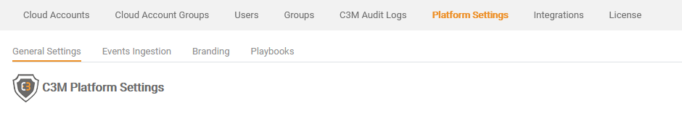

Click on **Events Ingestion**

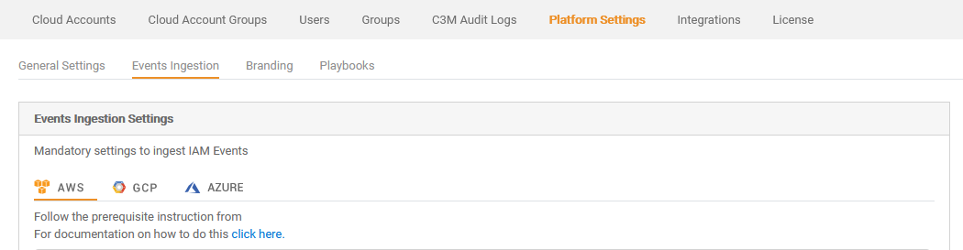

Choose **AZURE**

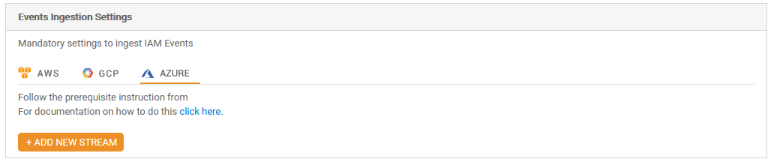

Click on **ADD NEW STREAM**

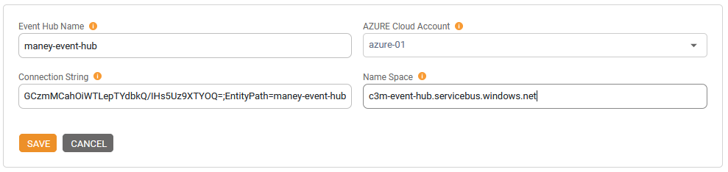

Enter Event Hub Name, Connection String and Name Space and click Save.